1. **Popular Wine Varieties**

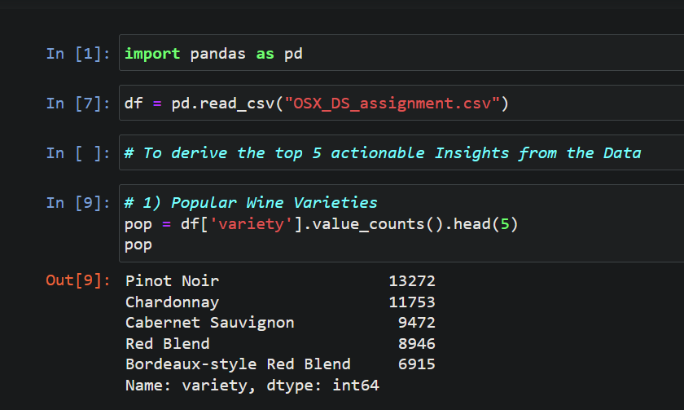

1. **Scatter plot of points vs. price**

*Helps in analyzing the insights on the price-value proposition*

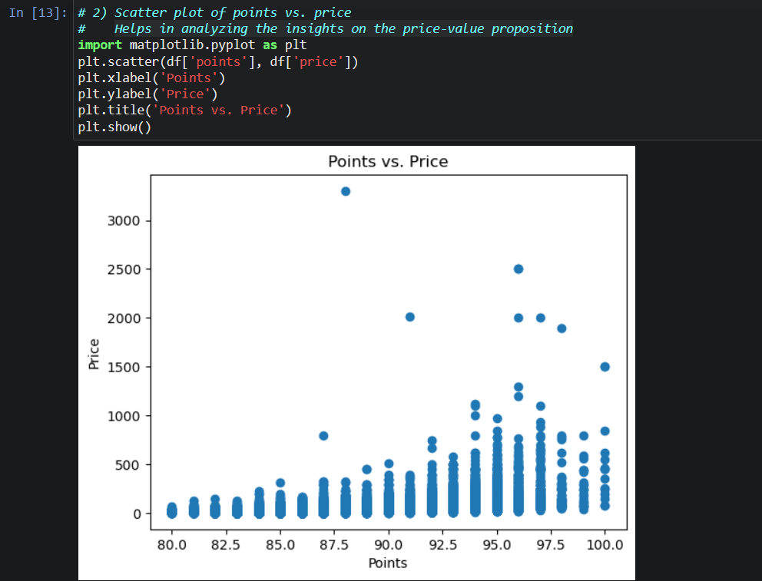

1. **Count the number of wines by country**

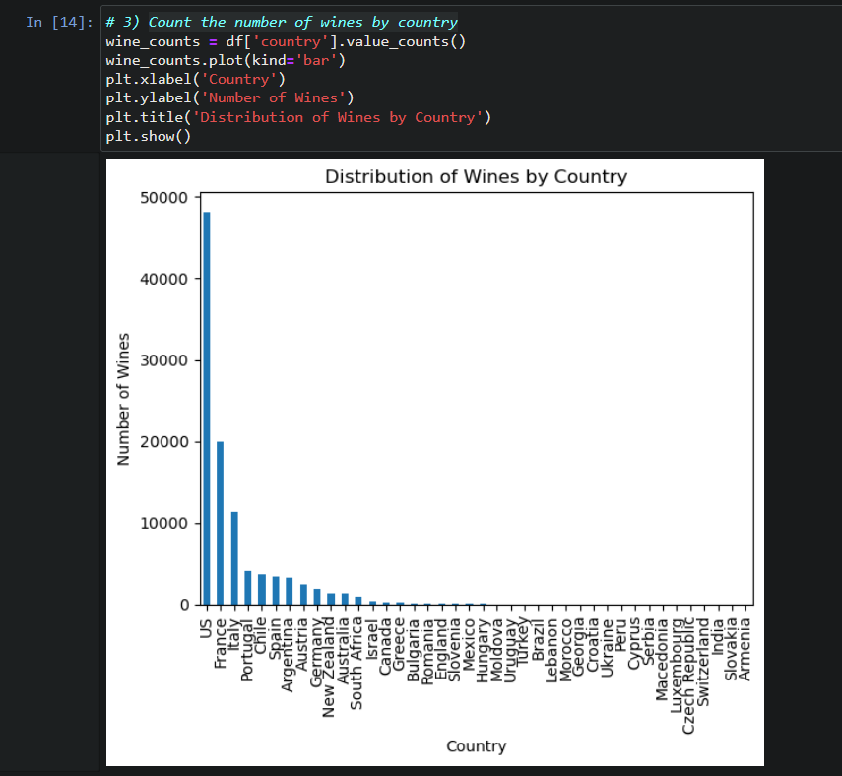

1. **Wine Recommendations and Pairings**

* Utilize the review data to generate personalized wine recommendations for customers based on their preferences.
* Analyze the reviews that mention food pairings to suggest suitable wine and food combinations.
* Provide targeted recommendations to customers, increasing their satisfaction and likelihood of making repeat purchases.

1. **Influencer Analysis**

* Identify influential reviewers or critics who have a significant impact on customer perception and purchase decisions.
* Analyze their reviews and ratings to understand their preferences and biases.
* Collaborate with influential individuals to promote the store's offerings and increase brand visibility.